Intake Agent
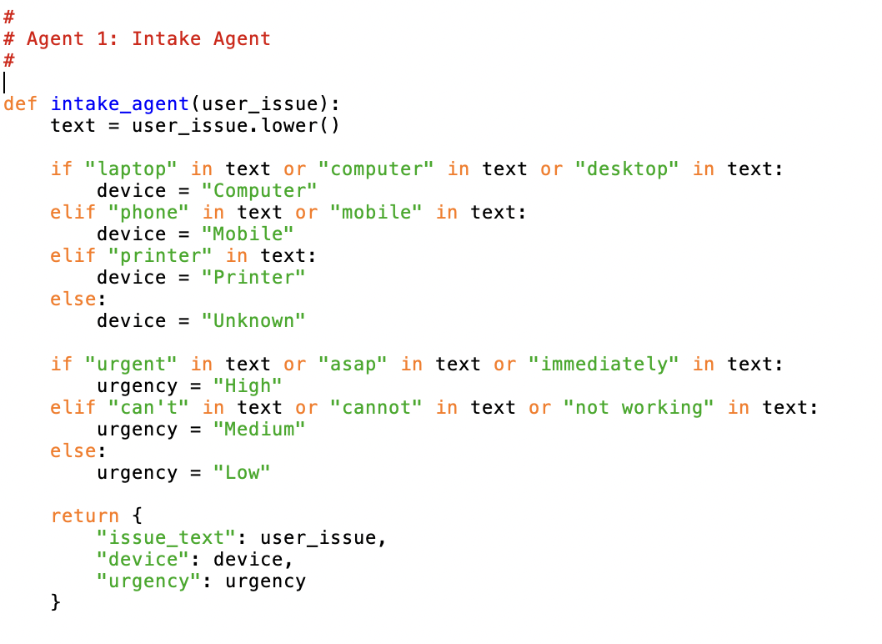
The Intake Agent is used to receive user input and extract key details from the user submission. The input is the user_issue submitted by the user. Depending on the keywords listed in user_issue, the intake agent will determine the type of device the user is experiencing the issue on, and it will also attempt to discern the urgency of the issue listed. The output is the user_issue, the type of device, and the urgency level of the issue.

Classification Agent
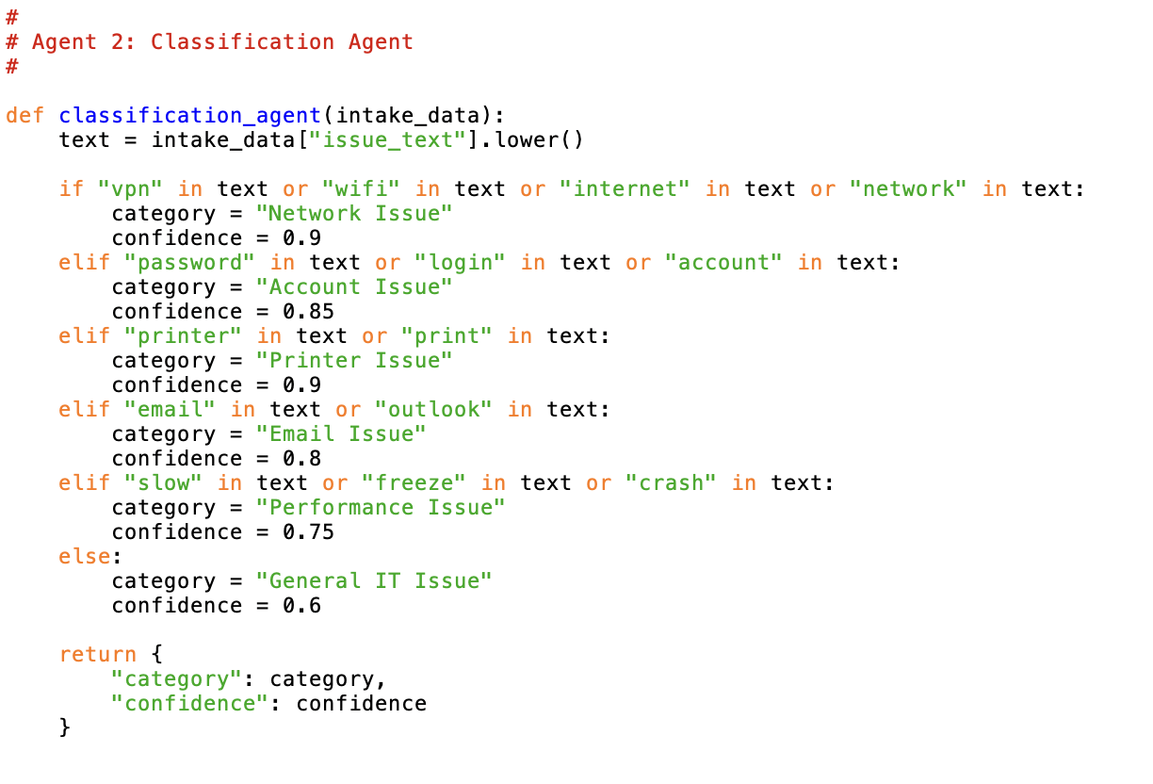
The job of the Classification Agent is to take the data input provided from the Intake Agent and determine the category of user_issue that the user is facing. The agent takes the intake_data and searches for commonly mentioned IT issues such as vpn issues or email issues. When found, the agent then assigns a category to the issue, as well as its confidence level in its categorization as the output.

Diagnostic Agent
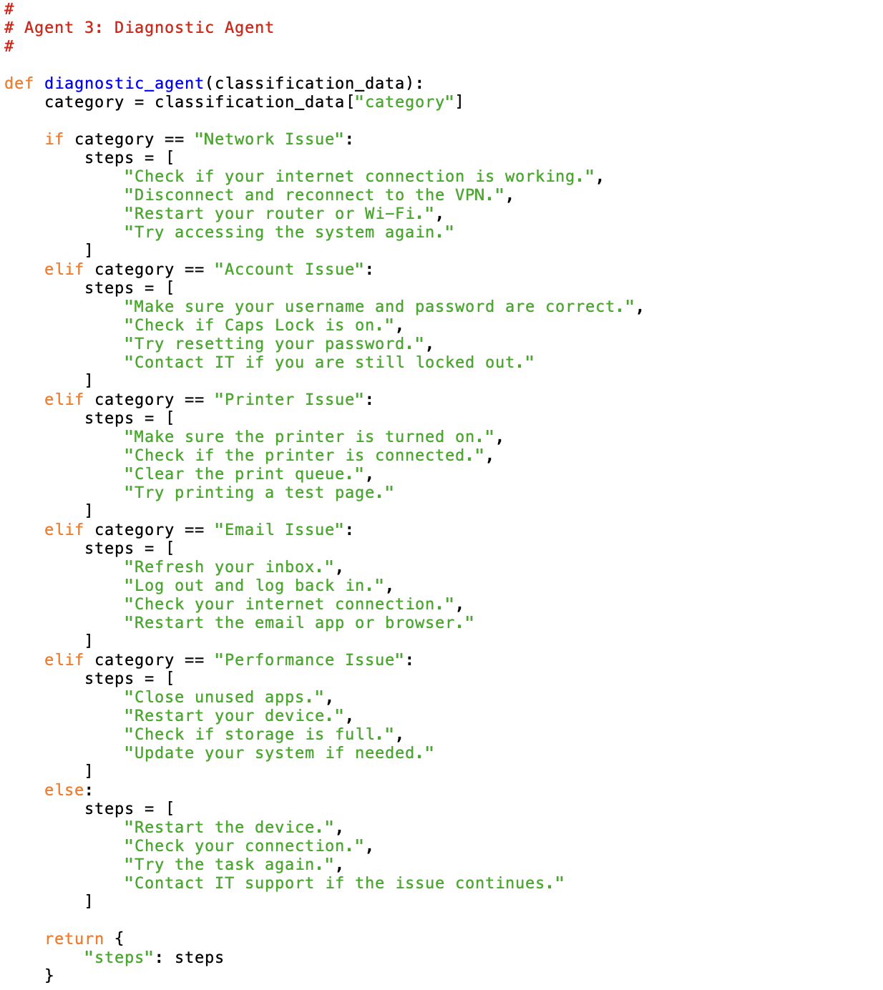
The job of the Diagnostic agent is to determine possible fixes for the user issue and supply step-by-step solutions that the user can reasonably follow to fix their issue. The input is the issue category taken from the Classification Agent to determine what category of fix should be looked for. The output from the Diagnostic Agent is the list of potential fixes for the user issue, and the steps.

Tool Agent
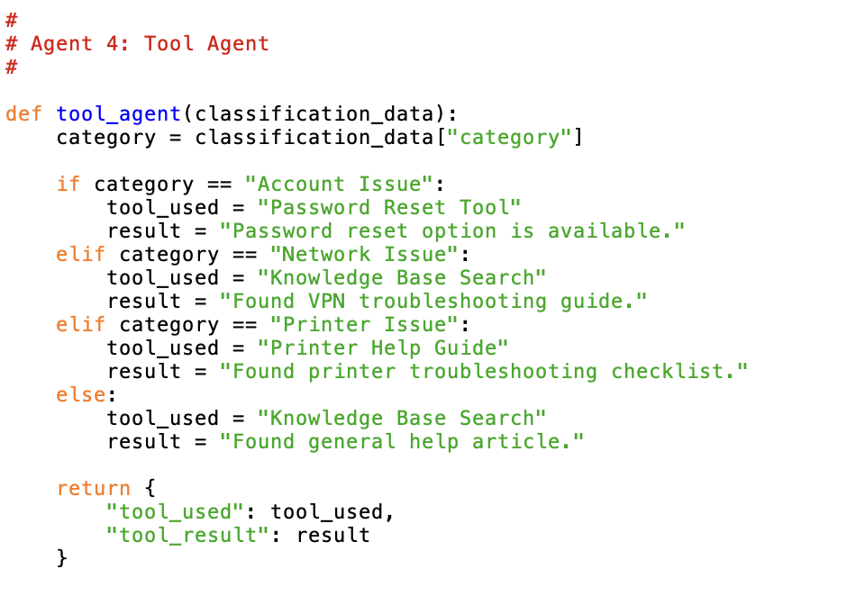
The job of the Tool Agent is to determine which tools are necessary to carry out the proposed fixes from the Diagnostic Agent. The input comes from the Classification Agent as the classification_data which allows the tool agent to determine which tools should be called. For the moment the tools are simulated in a list of Knowledge Base Search, Password Reset Tool, and Printer Guide. The output from this agent is the tool_used and the result.

Critic Agent
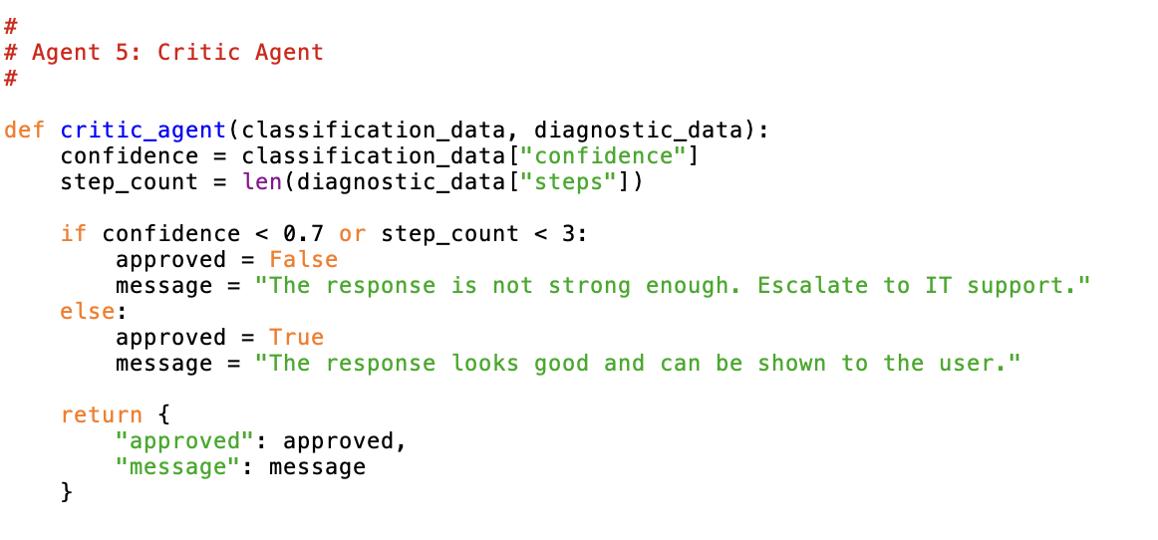
The Critic Agent is responsible for reviewing the response given by the other agents through the input of classification_data and diagnostic_data, and determining whether or not the responses are sufficient. It must then decide to show the response to the user if deemed sufficient or escalate the issue to the IT support team if the responses are deemed insufficient. This would be considered a low-quality output or failed output, therefore requiring escalation to the human team. The output would be considered the approved state (True False) of the responses determined by the confidence level of the agent.

This design document and corresponding code serves as the framework for the future workflows to be added so the system as a whole can operate more efficiently. I am still on the fence about which platform to use for the final implementation.

Risks | Mitigation Plan
 | Design & Development of Agent | Agent Integration into Processes
Adversarial Attacks | Limit the agent’s ability to disregard its own programming through prompting | Ban use of certain prompts when prompting the agent that could harm the integrity of the agent
Bias and Discrimination | Test the agent on various bias-prone systems to see how it performs | Deploy random checks/audits to ensure agent is not exhibiting bias
Misinformation and Hallucinations | Test agent to see how often it is providing misinformation and compare it to similar human scores prior to deployment | Have another agent verify the correctness of the information provided by the main agent
Data Privacy Violations | Ensure there are ample restrictions on the agent to make sure it is only accessing data that is necessary | Run random checks to ensure no data is being leaked through the agent
Intellectual Property Risks | Implement terms and conditions to protect yourself from legal issues | Inform users that intellectual property violations are a risk and must be monitored while using the platform

